Paper ###-2021 (if SAS author, use SAS###-2021 or SAS####-2021)

Title for SAS® Global Forum 2021 Sample Paper

Author 1 name, ABC Corporation; Author 2 name, DEF Corporation;   
Author 3 name, GHJ University

OR

Author 1 name, Author 2 name, and Author 3 name, SAS Institute Inc.

# Abstract

This paragraph uses the PaperBody style, which uses the Verdana font, not the Arial font.

# Introduction

This paragraph uses the PaperBody style, which uses the Verdana font, not the Arial font.

# First Main Topic <heading 1>

This is a main topic in the body of the paper. This paragraph uses the PaperBody style, which uses the Verdana font, not the Arial font.

If you need to include source code, introduce it with a sentence that ends with a colon:

proc ds2;

data _null_;

method init();

dcl varchar(16) str;

str = 'Hello World!';

put str;

end;

enddata;

run;

quit;

Figure 1 is a sample figure.

Figure 1. Caption for Sample Figure

## Subhead A Level <heading 2>

This is a subtopic of a main topic. This paragraph uses the PaperBody style, which uses the Verdana font, not the Arial font.

Table 1 is a sample table.

| SAS Variable Format | DB2 Data Type |
| --- | --- |
| $*w*.  $CHAR*w*. | CHARACTER |
| any date format | DATE |

Table 1. DBLOAD Procedure: Default DB2 Data Types for SAS Variable Formats

# Second Main Topic <heading 1>

This is a main topic in the paper. This paragraph uses the PaperBody style, which uses the Verdana font, not the Arial font.

1. This is a sample numbered or ordered list item. This is list item text. This is list item text. This is list item text.
2. This is a sample numbered or ordered list item. This is list item text.

This is another sample paragraph. This paragraph uses the PaperBody style, which uses the Verdana font, not the Arial font.

* This is a sample bulleted list item. This is list item text. This is list item text. This is list item text. This is list item text.
* This is a sample bulleted list item. This is list item text.

This is a continuation of the body of the paper—after an unordered list. This paragraph uses the PaperBody style, which uses the Verdana font, not the Arial font.

Display 1 is sample display or screen capture.

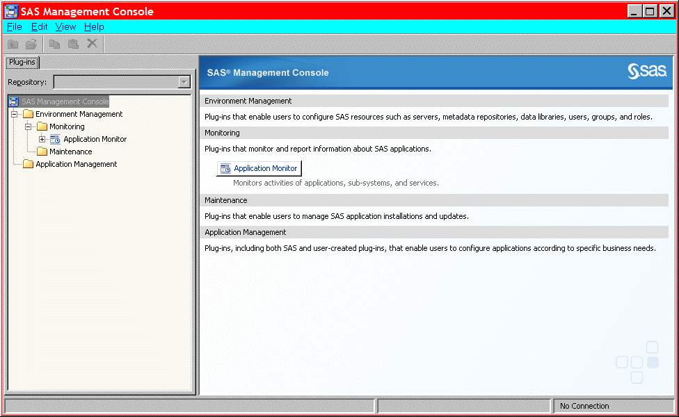

Display 1. Former Main Interface for SAS Management Console

## Subhead A Level <heading 2>

This paragraph uses the PaperBody style, which uses the Verdana font, not the Arial font.

Output 1 shows an example of how to present output.

CREATE TABLE ALLACCTX(SourceSystem varchar(4),

cctnum numeric(18,5) CONSTRAINT "ALLACCT_PK" PRIMARY KEY,

ccttype numeric(18,5),balance numeric(18,5),clientid numeric(18,5),

losedate date,opendate date,primary_cd numeric(18,5),status varchar(1))

Output 1. Output from a CREATE TABLE Statement

## Subhead A Level <heading 2>

This paragraph uses the PaperBody style, which uses the Verdana font, not the Arial font.

### Subhead B Level <Heading 3>

This is a subtopic of a subtopic. This paragraph uses the PaperBody style, which uses the Verdana font, not the Arial font.

#### Subhead C Level <Heading 4>

This paragraph uses the PaperBody style, which uses the Verdana font, not the Arial font.

# Conclusion

This paragraph uses the PaperBody style, which uses the Verdana font, not the Arial font.

# References

Book <Author name: last name, first name (or initials)>. <Publication date>. <*Book title*>. <City, State (abbrev) of publication> : <Publisher name>.

Journal article <Author name: last name, first name>. <Publication date>. “<Article title>.” <*Journal title*>, <volume no.:page numbers>.

Article in conference proceedings <Author name: last name, first name>. <Publication date>. “<Article title>.” <*Title of proceedings such as Proceedings of the SAS Global 2010 Conference*>, <City, State (abbrev) of publication> : <Publisher name>. Optional: You can add a URL to access available online proceedings. For example: Available at <http://support.sas.com/resources/papers/proceedings09/TOC.html>.

Website <Author name: last name, first name>. “<Title>.” <*Source*>. <Date>. Available at <URL>.

Reference examples:

Book Agresti, A. 2013. *Categorical Data Analysis*. 3rd ed. Hoboken, NJ: John Wiley & Sons.

Journal article Akaike, H. 1979. “A Bayesian Extension of the Minimum AIC Procedure of Autoregressive Model Fitting.” *Biometrika,* 66:237–242.

Article in conference proceedings Dorfman, A. H. and R. Valliant. 1993. “Quantile Variance Estimators in Complex Surveys.” *Proceedings of the Survey Research Methods Section*, 866–871. Alexandria, VA: American Statistical Association.

Website Federal Reserve Bank of St. Louis. 2012. “Economic Research.” Accessed November 7, 2012. <http://research.stlouisfed.org>.

# Acknowledgments

This is the text for the acknowledgments. This paragraph uses the PaperBody style, which uses the Verdana font, not the Arial font.

# Recommended Reading

* *Base SAS® Procedures Guide*
* *SAS® For Dummies®*

# Contact Information <heading 1>

Your comments and questions are valued and encouraged. Contact the author at:

<Name>

<Enterprise (optional)>

<Phone (optional)>

<E-mail>

<Web (optional)

SAS and all other SAS Institute Inc. product or service names are registered trademarks or trademarks of SAS Institute Inc. in the USA and other countries. ® indicates USA registration.

Other brand and product names are trademarks of their respective companies.

**Delete the following instructions**.

Basic Instructions

## Writing Guidelines

### Trademarks and product names

To find correct SAS product names (including use of trademark symbols), if you are a SAS employee, see the [Master Name List](http://sww.sas.com/sasnaming/). Otherwise, see [SAS Trademarks](http://www.sas.com/en_us/legal/trademarks.html).

* Use superscripted trademark symbols in the first use in title, first use in abstract, and in graphics, charts, figures, and slides.
* Do not abbreviate product names. For example, you cannot use “EM” for SAS® Enterprise Miner™. After having introduced a SAS product name, you can occasionally omit “SAS” for certain products, provided that your editor agrees. For example, after you have introduced SAS® Simulation Studio, you can occasionally use “Simulation Studio.”

### Writing style

* Use active voice. (Use passive voice only if the recipient of the action needs to be emphasized.) For example:

The product creates reports. (active)  
Reports are created by the product. (passive)

* Use second person and present tense as much as possible. For example:

You get accurate results from this product. (second person, present tense)  
The user will get accurate results from this product. (future tense)

* Run spellcheck, and fix errors in grammar and punctuation.

### Citing references

All published work that is cited in your paper must be listed in the REFERENCES section.

If you include text or visuals that were written or developed by someone other than yourself, you must use the following guidelines to cite the sources:

* If you use material that is copyrighted, you must mention that you have permission from the copyright holder or the publisher, who might also require you to include a copyright notice. For example: “Reprinted with permission of SAS Institute Inc. from *SAS® Risk Dimensions®: Examples and Exercises*. Copyright 2004. SAS Institute Inc.”
* If you use information from a previously printed source from which you haven’t requested copyright permission, you must cite the source in parentheses after the paraphrased text. For example: “The minimum variance defines the distance between cluster (Ward 1984, p. 23)

## Tips for using Word

### To select a paragraph style

1. Click the HOME tab. The most common styles in your document are displayed in the top right area of the Microsoft ribbon. If you don’t see a style that you want, click the slanted down arrow at the bottom right corner of the Styles area, and scroll through the list. The main styles for this template are headings 1 through 4, PaperBody, and Caption. Avoid using other styles.
2. To change a paragraph style, click the paragraph to which you want to apply a style, and then click the style that you want in the ribbon.
3. PaperBody (used for most text) is automatically applied when you press Enter at the end of any heading style or the Caption style.

### To insert a caption

1. Click **REFERENCES** on the main Word menu.
2. Click **Insert Caption**.
3. Select the **Label** type that you want.
4. Click **OK**.

### To insert a graphic from a file

1. Click **INSERT** on the main Word menu.
2. Click **Picture**.
3. In the Insert Picture dialog box, navigate to the file that you want to insert.
4. When the name of the file that you want to insert is displayed in the **File name** box, click **Insert**.